DAY 7 – 17.04.2024

FORENOON SESSION SCREENSHOTS

EQUALS AND” == “OUTPUT:

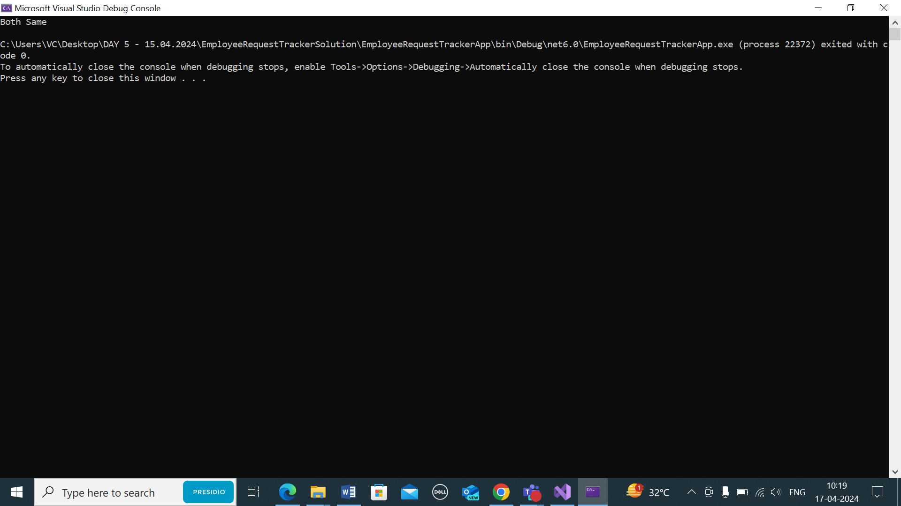

UNDERSTANDING HASHSET:

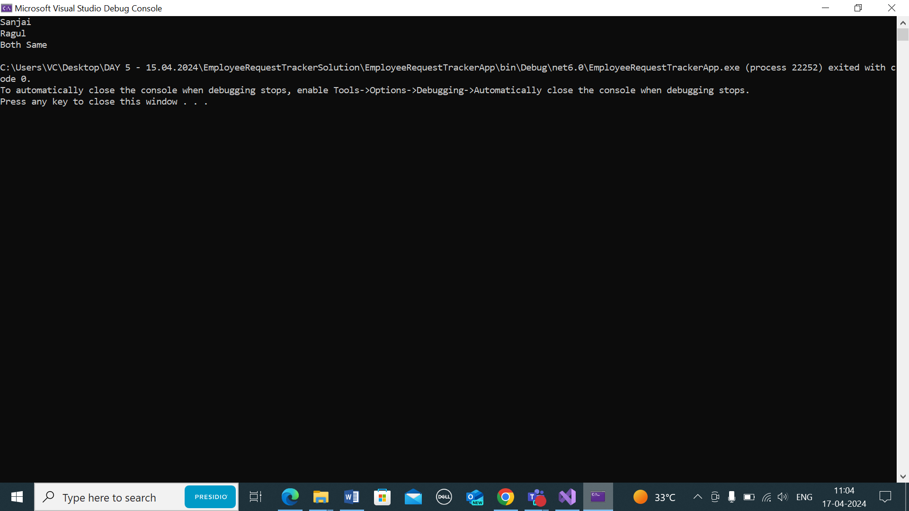

UNDERSTANDING LIST AND GENERIC LIST:

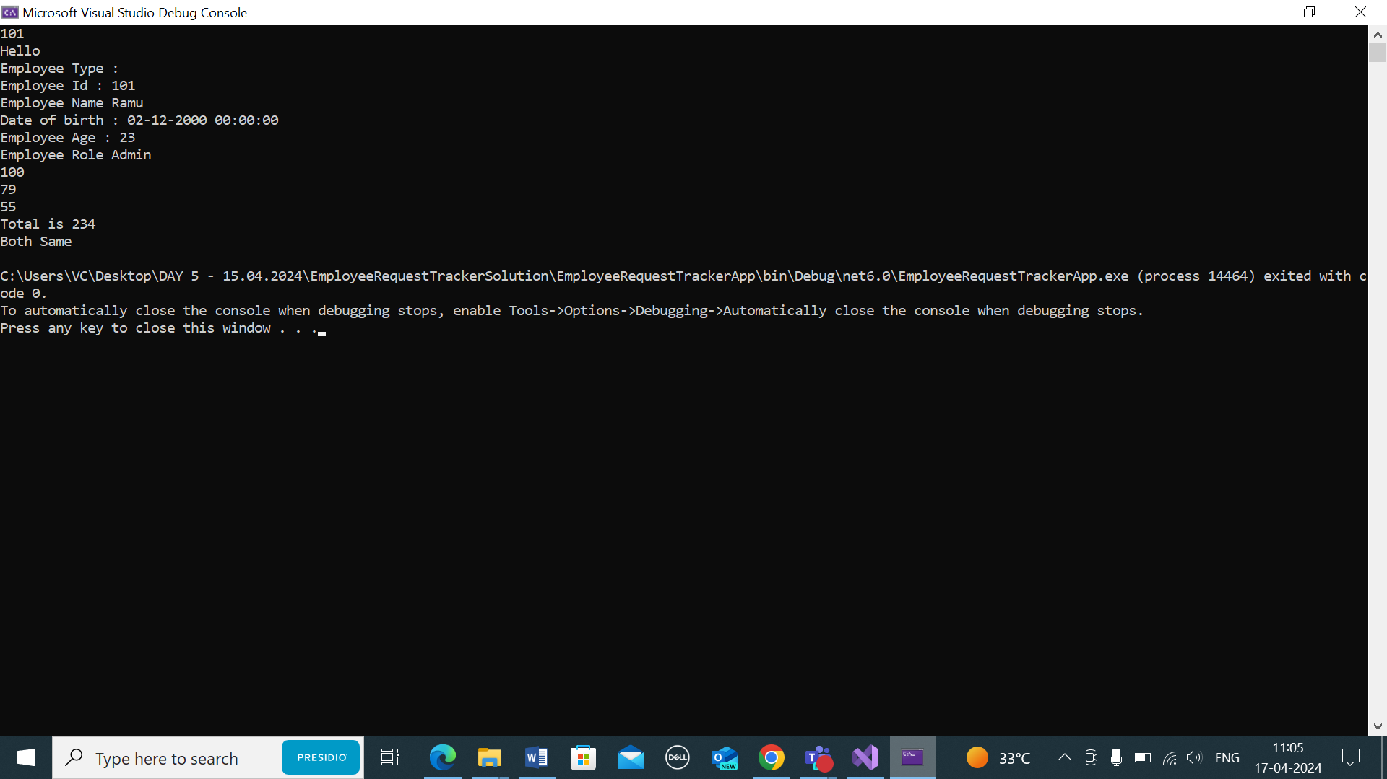

UNDERSTANDING DICTIONARY:

